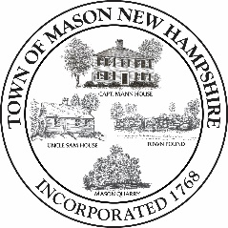
Filing for Town Office

I, _______________________________, declare that I reside in the Town of Mason, County
of Hillsborough, State of New Hampshire, and that I am a qualified voter therein; that I am a candidate for the office of _________________________ and I hereby request that my name
be printed on the official non-partisan ballot of the Town of Mason.

Signed (name as you wish it to appear on the ballot): ________________________________________

Address:___________________________________________________________________

Date of Declaration: _________________________________________________________

Signature of Town Clerk: _____________________________________________________

